**INTRODUCTION**

Thermal Analysis-

The Thermal analysis is used to determine the temperature distribution and related thermal quantities such as: thermal distribution, amount of heat loss or gain, thermal gradient and thermal fluxes.

All primary heat transfer modes such as conduction, convection and radiation can be simulated. There are two types of Thermal Analysis (namely as followed)-

Steady State Thermal Analysis- In this analysis, the system is studied under steady thermal loads with respect to time.

Transient Thermal Analysis- In this analysis, the system is studied under varying thermal loads with respect to time.

**1. Steady state thermal analysis**

Solver- ANSYS Workbench

**Specifications:?**

Material- Aluminium alloy

**Analysis Boundary Conditions-**

Heat Input- 1132 W

Convective heat transfer coefficient(over complete disc)- 40 W/m2K

**Results-**

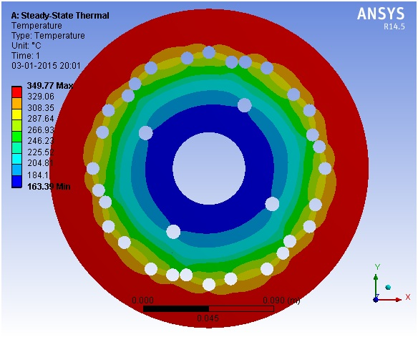

Temperature Distribution Contour

**2. Transient Thermal Analysis**

Solver- ANSYS MECHANICAL APDL

**Specifications:?**

Material- Aluminium alloy

**Analysis Boundary Conditions-**

Temperature Input along the periphery- 349.770C

Convective heat transfer coefficient (over complete disc)- 40 W/m2K

**Results-**

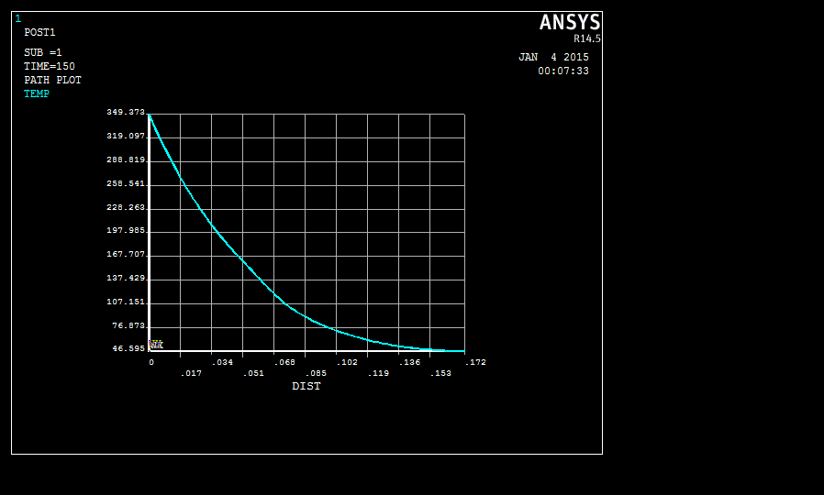

Radial temperature variation along the disc with respect to time

**Conclusion-**

Under ideal running conditions the brake disc will cool down to atmospheric temperature approximately within 3 minutes.

**INTRODUCTION**

Fluid Flow Analysis-

This analysis is used to determine the flow distribution and temperature variation during the flow conditions of the fluid. The ANSYS/FLOTRAN and ANSYS FLUENT program is used to simulate the laminar and turbulent flow, compressible fluid flow conditions, automotive design, etc. The outputs that can be expected from the fluid flow analysis are Velocities, Pressures, Temperatures and Film Coefficients.

**1. Temperature drop within the radiator tubes**

**Tube specifications:**

Inner diameter- 8 mm

Material- Copper

**Solver-** ANSYS FLUENT

**Solver Specifications-**

type- pressure based & velocity formulation- absolute

time- steady

Viscous model- k-epsilon

k-epsilon model- RNG

Near wall treatment- Enhanced wall treatment

**Analysis Boundary Conditions-**

Mass flow rate at inlet- 0.025 kg/s

Outlet pressure- 1.01325*105 Pascal

**Solution Methods-**

Pressure-Velocity Coupling Scheme- simple

Spatial Discretization-

Gradient- Least Square cell based

Pressure- Standard and second order

Momentum- First order upwind and second order upwind

Turbulent Kinetic Energy- First order upwind and second order upwind

Turbulent Dissipation Rate- First order upwind and second order upwind

**Results-**

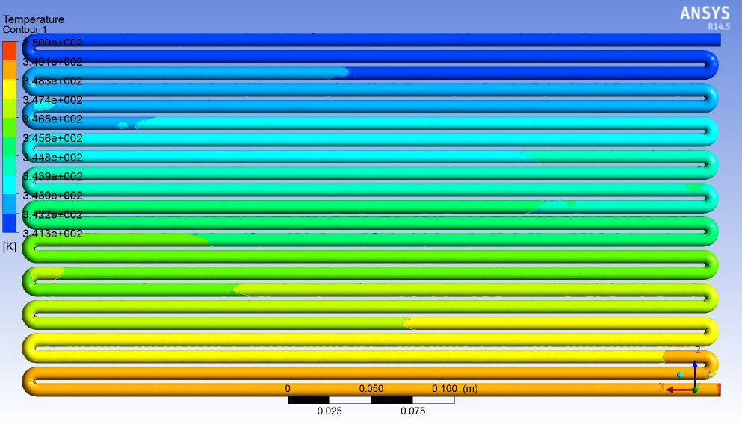

Temperature drop within the bare radiator tubes

**Conclusion-**

Using only bare copper tubes in the radiator the temperature drop approximately by 100C.

**2. Analysis of the solid car model for coefficient of drag**

**Solver-** ANSYS FLUENT

**Solver Specifications-**

type- pressure based & velocity formulation- absolute

time- steady

Viscous model- k-epsilon

k-epsilon model- Realizable

Near wall treatment- Non equilibrium wall function

**Analysis Boundary Conditions-**

Inlet Velocity- 33m/s (at the entry of wind tunnel)

Outlet pressure- 1.01325*105 Pascal (at the exit of wind tunnel)

**Solution Methods-**

Pressure-Velocity Coupling Scheme- simple

Spatial Discretization-

Gradient- Least Square cell based

Pressure- Standard and second order

Momentum- First order upwind and second order upwind

Turbulent Kinetic Energy- First order upwind and second order upwind

Turbulent Dissipation Rate- First order upwind and second order upwind

**Results-**

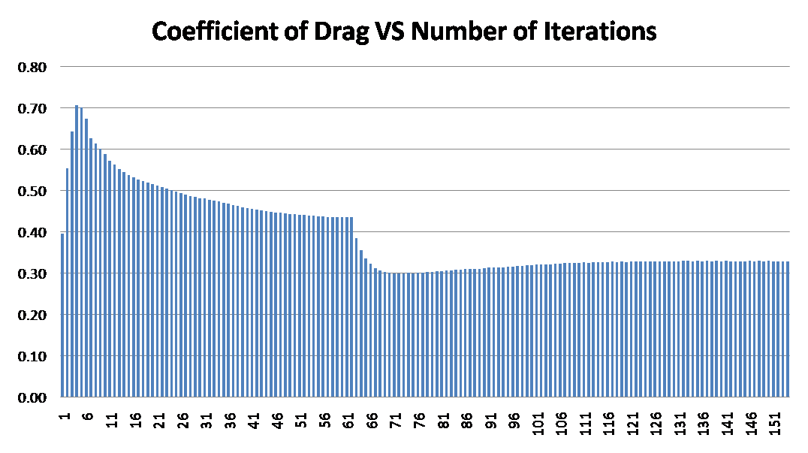

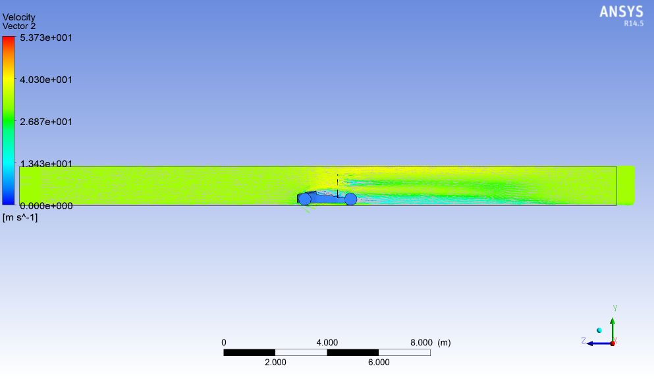

velocity vector (on vertical plane)

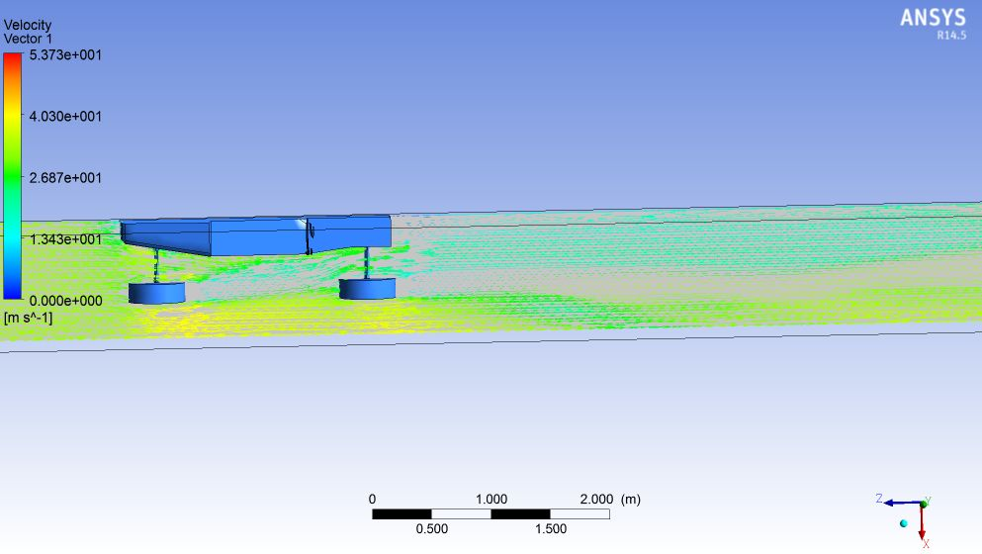

velocity vector (on horizontal plane)

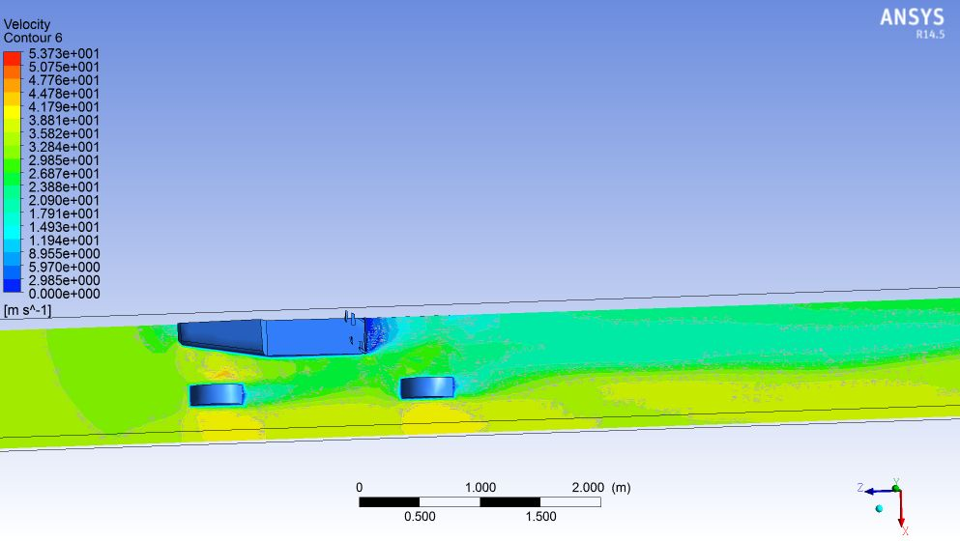

velocity contour (on horizontal plane)

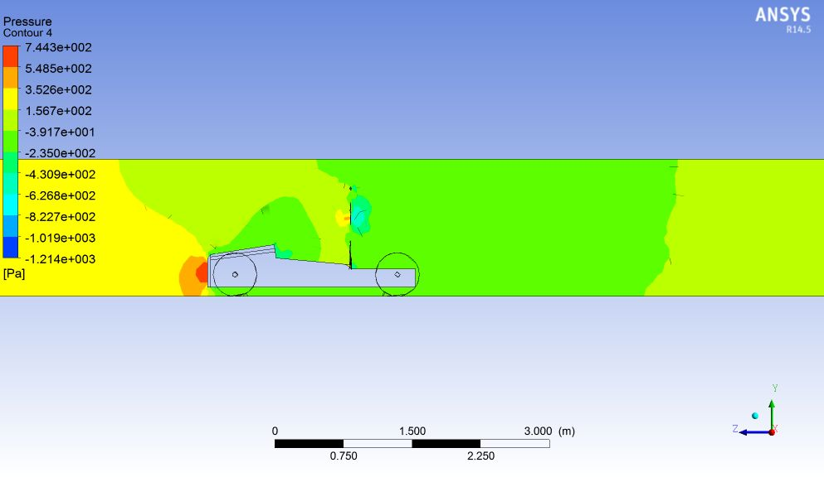

Pressure contour

**Conclusion-**

The coefficient of drag is approximately 0.32.

**3. VENTURI**

**Venturi specifications-**

Throat diameter- 20 mm

Convergent and divergent section diameter- 40 mm

Convergent length- 6.5 mm

Throat length- 10 mm

Divergent length- 128.2 mm

Overall length- 8 inch

**Solver-** ANSYS FLUENT

**Solver Specifications-**

type- pressure based & velocity formulation- absolute

time- steady

Viscous model- k-epsilon

k-epsilon model- Standard

Near wall treatment- Standard wall function

**Analysis Boundary Conditions-**

Inlet pressure- 1.01325*105 Pascal

Inlet temp – 300 K

Fluid- Air

Mass flow rate- 0.0703 kg/s

**Solution Methods-**

By equation of mass flow rate of compressible fluid for air,

$m=\frac{AP}{\sqrt{T}}\sqrt{\frac{γ}{R}}{\left(\frac{γ+1}{2}\right)}^{-\frac{γ+1}{2(γ-1)}}$

Where, A- area at throat=0.001256m2

P- Pressure at inlet=101325 N/m2

T- Temperature at inlet=300

R- Gas constant for air=0.287

$γ$-isentropic constant=1.4

Pressure-Velocity Coupling Scheme- simple

Spatial Discretization-

Gradient- Least Square cell based

Pressure- Standard and second order

Momentum- First order upwind and second order upwind

Turbulent Kinetic Energy- First order upwind and second order upwind

Turbulent Dissipation Rate- First order upwind and second order upwind

**Results-**

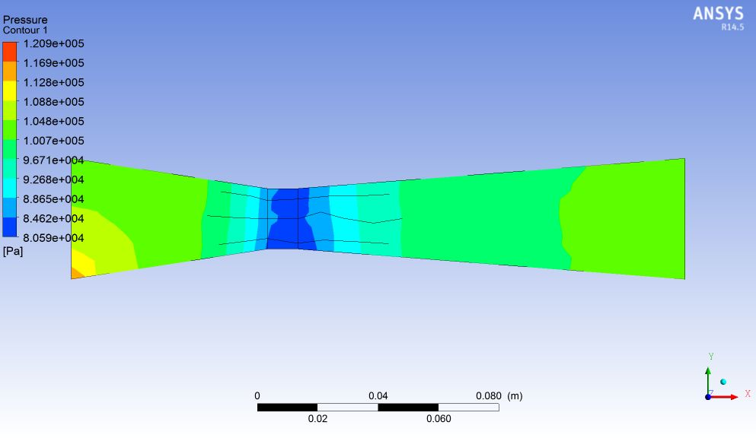

Pressure distribution within the venturi

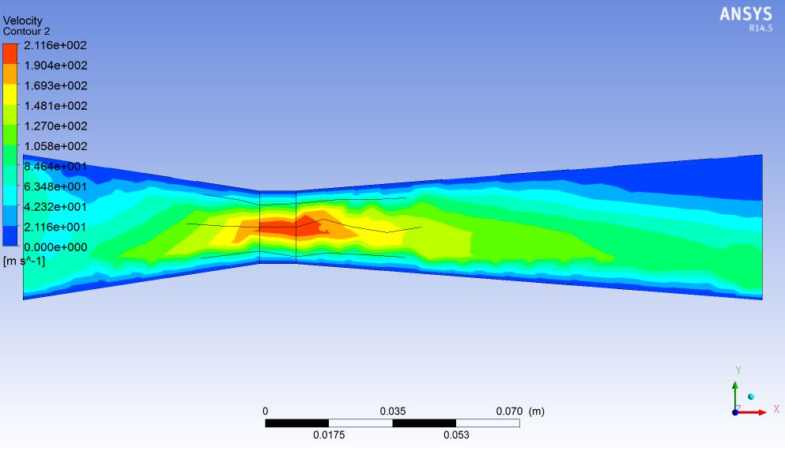

Velocity contour within the venturi

**Conclusion-**

The pressure drop within the venturi is approximately 0.19 bar with a throat pressure of 0.8059 bar.